Version 2026-04-06 15:33, Eric Pohl

Measurements (discharge)
The principal method that is explained in the following is the dilution tracer method using Sodium-Fluoresceine as dye tracer and an Albillia FL30 fluorometer. The instrument (Chapter 2.2), the required materials and installation setup (Chapter 3.2), as well as the preparation of calibration liquid and vials (Chapter 5) are explained in different documents. The focus of this document is the measurement using the fluorometer.
It is very important to have the fluorometer acclimatized – the fluorometer must be cooled down slowly by pouring small amounts of cold river water over it every minute for at least 5 minutes. It is important to never directly put a warm fluorometer in cold water because it can break!

Turn on fluorometer
The fluorometer needs to be connected with the cable. There is a bayonet connector. Make 100% sure it is properly connected – the connecter must tightly be in place, with no gap in between the two parts of the connector (https://www.youtube.com/watch?v=1zlmDIvj8tw), otherwise it can loosen and we can lose the instrument! Connect the other side of the cable to the logger box. Inside the logger box (might deviate slightly depending on your logger version) you will find the two connecting cables for the battery. You must use a 12V battery. A charged 7Ah battery is sufficient for a field site. If you plan to do work at multiple field sites, bring a 12V battery charger, that you can attach in a car.
The battery needs to be connected to the cables. The display will turn on. The old loggers (plastic box inside the logger box) will ask you how you want to setup the instrument now. Choose:
- 2 second interval
- Tracer: Uranine/Fluoresceine (Tracer 1) / Optics 1
- No PC connected
- Show times 10 (x10)
- Show PPB
These settings are setup in newer versions of the logger with switch buttons that can be changed during the operation. The acclimatized FL30 can be placed in the stream while the rest of the calibration and measurements are being prepared. This helps to cool the instrument further to the river water temperature. It also removes some possible contamination with fluoresceine.
We choose the option to display ppb instead of mV. The instrument has an internal calibration to related mV to ppb. This is only giving us a first order estimate of the actual concentration. We must run our own calibration to get a reliable value. The display of ppb is only useful for a rough estimate of how much color is in the water! The “times 10” (x 10) option allows us to see also small variations in the concentration. We will try to have around 5 to 20 ppb as maximum concentration for our measurements. If we did not estimate the injection amount correctly (Chapter 5.3), and our signal is very low (around 2 to 5 ppb), the signal might still look good, and we can use it later in the post-processing. To see if the signal is good (Figure 1), the “times 10” function is very useful as it can show us if the signal increases without jumping. An example for a bad measurement is shown in Figure 2. Here the display on the FL30 will show us a lot of jumping. This can be very well seen with the x10 option selected.
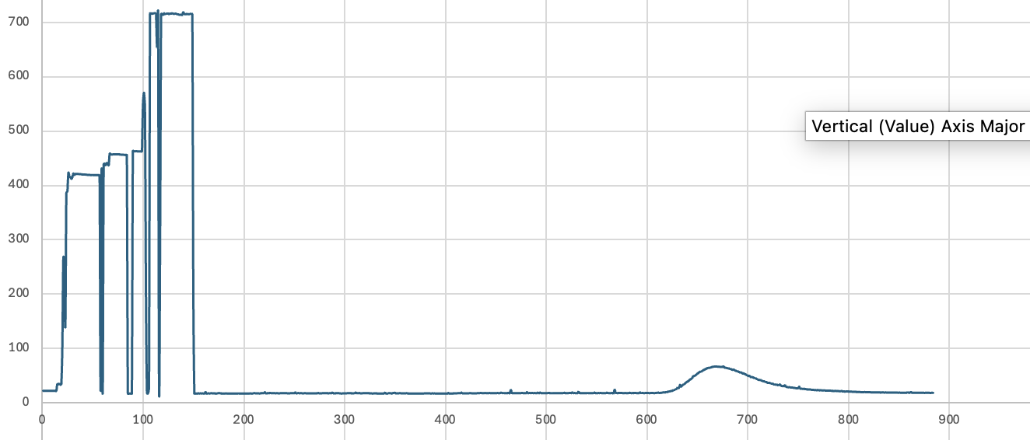
Figure 1: Example of low color amount injection. The signal is very smooth and we can use this still for the calculation of discharge.
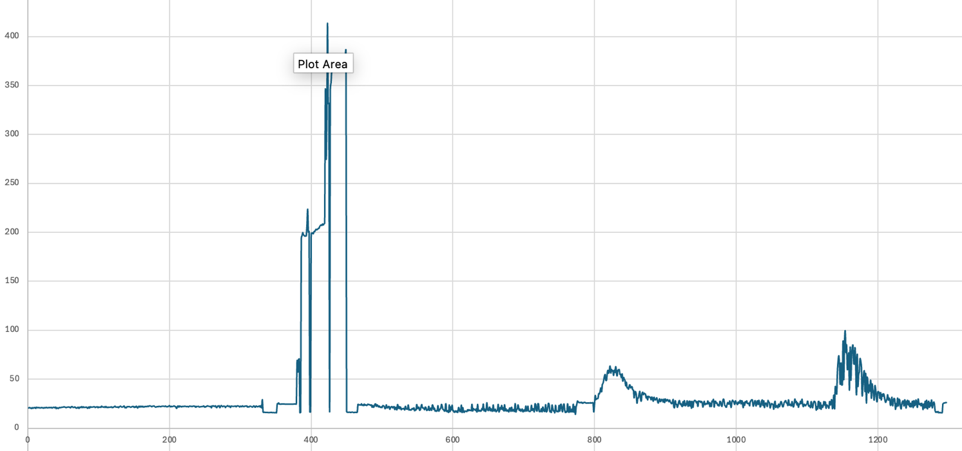
Figure 2: Example of injection with more color but very bad signal. The signal (right side) shows a lot of spikes. On the FL30 display we can see that the signal is jumping: low and high values instead of a continuous increase and decrease. These measurements have a very high uncertainty and might not be useful at all.

Calibration
The FL30 measures the fluorescent signal in mV. We need to establish a relationship of this mV signal and the actual color concentration. For this, we must perform a calibration. Make sure that the FL30 is acclimatized (slowly cooled down to the water temperature by pouring small amounts of water over the instrument every other minute). Next, the bucket needs to be filled with 5L of river water:
- Rinse bucket
  - make sure there is no old Fluoresceine inside the bucket
  - bucket is cooled down
- Add 5L of river water using the 1L cylinder
- Place the FL30 into the bucket
- Make sure the display (logger) shows a signal strength of < 1 ppb. When the “times 10” option is selected < 10 (ppb * 10).
- If the signal shows a higher value, you have a contamination in the water and need to repeat the preparation.
If the signal is below 1 ppb, we can continue with the calibration. These are the steps:
- Take a calibration vial (any) from the lightproof bag
- Close the bag again (we want to prevent any sunlight exposure as the color deteriorates under sunlight
- Keep the vial in your hand to protect it from sunlight just before injection into the bucket.
- Clean the calibration in the vial (sometimes one of the vials might break during the transport and contaminate the other vials from the outside)
  - Submerge the vial in the river (not the bucket) and swipe it a few times with your hand to clean it from any potential contamination
- Open the vial and inject its content into the bucket
- Stir the water in the bucket with the FL30
  - Lift (gently) the FL30 by grabbing the cable
  - Move the FL30 in the bucket in circles to mix the water (30 seconds)
  - Lift the FL30 up and down in the bucket (5 times)
    - The measurement takes place inside the FL30 inside a glass tube
    - Lifting it up and down helps to mix and also make sure that the mixed liquid is reaching the glass tube
- Check the display
  - The signal should be somewhat close to the calculated ppb value (05 - Lab preparation v 2025-07-15 [EN] – The purple estimates of how much ppb we should get per calibration vial injection. It will most likely not be exactly this value but within a few ppb)
- Repeat the steps to add a 2nd and a 3rd calibration vial
- Each time you add one vial, the display should show a more or less a linear increase, e.g. 4, 8, 12 ppb (40, 80, 120 if the “times 10” option is used)
  - Because we use not exactly the same amount per calibration vial, you might observe some stronger variations
- Note down in your notebook how much calibration vial liquid you added each step
  - This is fundamentally important – without this information, we cannot do the post-processing
- You finished the calibration:
  - Take out the FL30
  - Discard the water from the bucket
  - We are ready for the measurement

Required materials:
- Notebook and pen
- Bucket 5L
- 1L cylinder
- 3 calibration vials (per measurement)

Injection and measurement
Place the FL30 at a suitable spot into the river (Chapter 3.2). Make sure it is protected from sliding into the river, and that it measures only the actual stream flow. You have determined a good spot for the injection (Chapter 3.2) and you are ready for the injection. One person of your team stays with the FL30 to check the signal (if the stream flow is fast than you walking back from the injection point to the FL30). The person at the FL30 can check if the signal looks good (Chapter 6.1).
Perform the following tasks:
- Take one injection vial from the opaque (100% sun protected) bag
  - Keep this in your pocket until you fill it later into the bucket
- Take the bucket and a 1L cylinder
- Move to the injection point (Chapter 3.2)
- Look for a place suitable for injection:
  - Upstream of a rapid, where water is quickly well mixed (e.g. Figure 3)
  - Safe: Never risk falling into the water where it is dangerous!
    - Above a rapid are often pools and big stones that provide a safe spot for injection
- Take a GPS point (if you have not done so already – needs to be done only one time)
- Place the bucket on the ground (stable)
- Fill the 1L cylinder (does not need to be 1L – just fill it up to any filling)
- Empty the injection vial into the bucket:
  - Make sure to hold the vial above the bucket at all time. If you spill something, you will spill it into the bucket!
  - Take the 1L cylinder and pour it over the vial cap to get all liquid from the cap also into the bucket
  - Pour more water over and in the actual vial now
    - You can pour water into the vial to let it overflow – as you are above the bucket, everything will go into the bucket
    - Repeat several time until the vial is completely clear
- Add 2 more times 1L into the bucket:
  - If you pour the water to the inside side of the bucket the water will swirl and mix the color.
  - Pour the water so that you collect all dye drops that are stuck on the bucket inside
- Injection:
  - Take a picture of the bucket (at best with the injection vial and readable amount of color on it) (Figure 3)
  - Pour the color mix in one go into the water (center of the stream) (Figure 4)
  - Rinse the bucket immediately (so the color that was still in the bucket is not disconnected from the main injection)
  - Bring back all material to the FL30 measurement position
- At the FL30 position observe the display of the logger.
- Note down at what time the signal starts to increase and when it starts to decrease and comes back to around 1 ppb
  - Add this information to the time of injection into your notebook
- Observe the signal regularly to ensure the signal is smooth
Required materials for the injection:
- Notebook and pen
- Bucket 5L
- 1L cylinder
- 1 injection vial (per measurement)

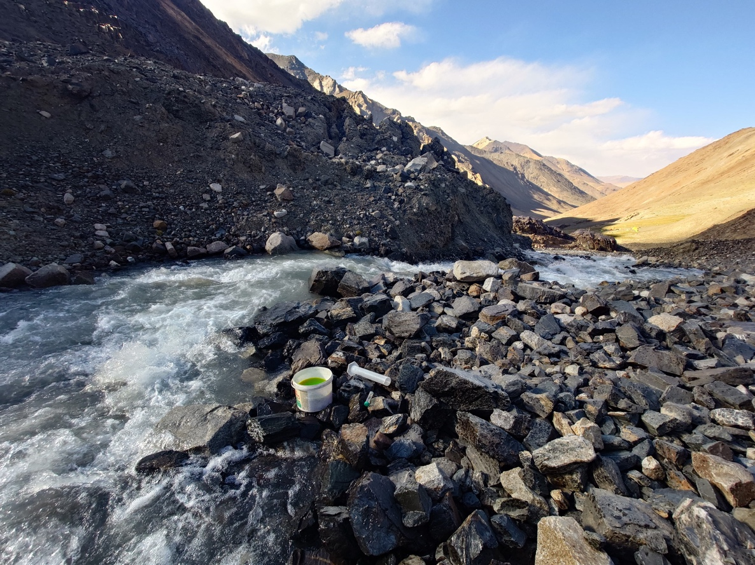
Figure 3: Prepared injection. Injection amount noted down in notebook. Photo serves to have the exact timestamp of when you did the injection. You can also place the injection vial on the photo so you can even reconstruct how much you injected.
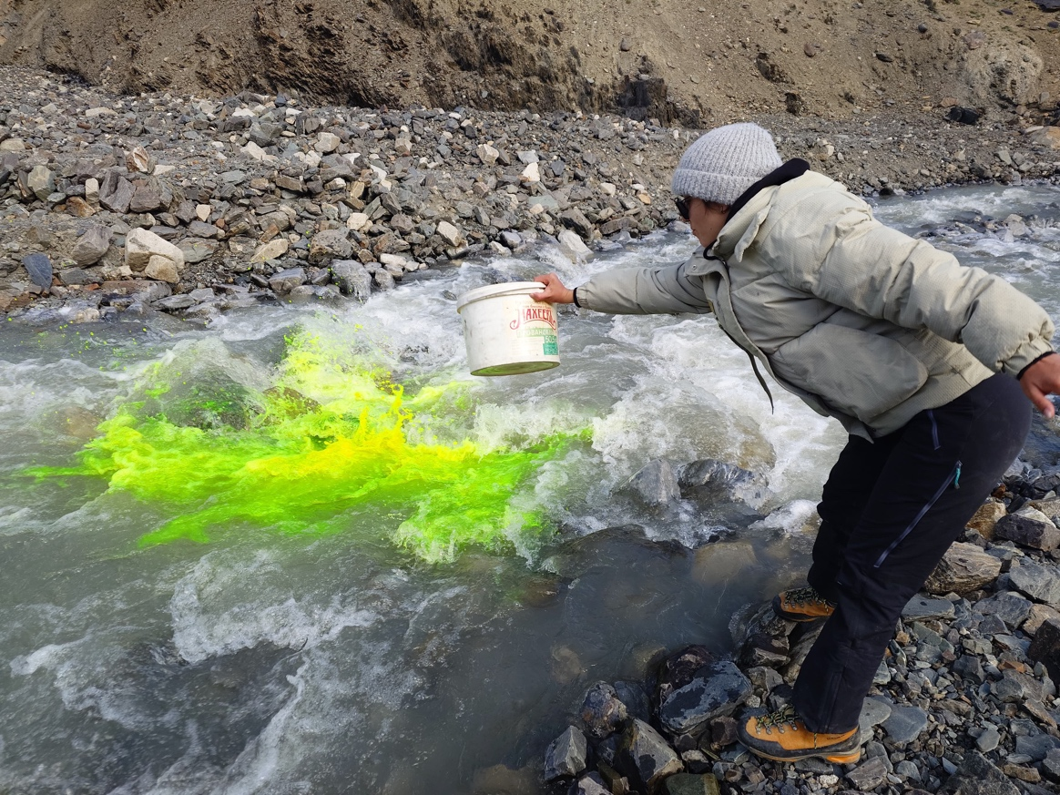
Figure 4: Injection. Immediately rinse the bucket at the same place afterwards. This must happen immediately.

